Creative Breif
  - 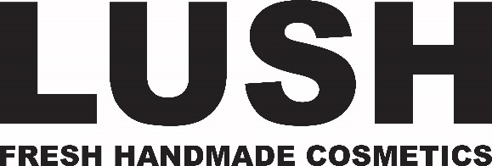

  - Current position
There is no current position for Lush men’s products.

DESIRED POSITION
Leading high end men’s care products in North America.

WHY SHOULD THEY THINK THIS?
All Lush products are handmade with quality ethically purchased organic ingredients. They not animal tested. Unlike their competitors they don’t need gimmicks to sell their products.

COMPETITORS
Axe, Old Spice, and Dove Men.

Client Issue
While Lush is a recognized cosmetic brand in both North America and the UK, their men’s product line has not been as recognized. Lush wants to promote these products and position these products as a high end sophisticated men’s line.

Objective
Increase brand awareness of Lush men’s care products by 20% by the end of 2017.

Target Audience/Consumer Insight
Men between the ages of 25-40 living in North America. They are college educated middle class to upper class men who care about fashion, art, and design. They care about product quality and ethically purchased products.

Key Message
That Lushes men’s products are quality and sophisticated. They don’t rely on gimmicks or machismo to sell their products. These are real organic products for real men.

