Creative Brief
  - 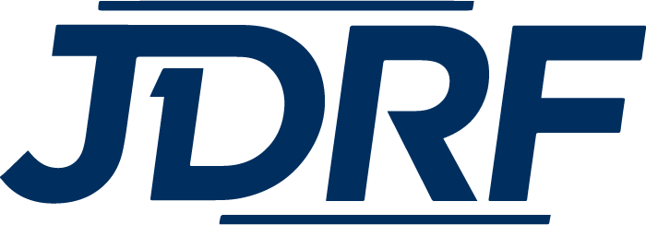

Key Message
You are not the only one struggling with Type 1 Diabetes. JDRF is your #1 support system for Type 1 Diabetes.

Audience Insight
People tend to become involved with nonprofit organizations because the cause directly relates to them or a loved one. Many are comfortable with making donations or participating fundraising event such as the One Walk.

The Client
Issue
The main objective of this campaign is to raise brand awareness of JDRF in Kent County. We want to do this by creating an inclusive campaign around the T1D community.
Brand position
At a national level JDRF has high level brand recognition with its target audience. However, at the regional level with the Michigan Great Lakes Chapter, there is low brand recognition.
The Consumer
Demographics
Non-Hispanic Whites between the ages of 21-44 living in Kent County.
Psychographics
The target audience is interested in Type 1 Diabetes. They may be effected or has someone close to them effected by T1D. They want to assist in relieving T1D. This issue deeply effects their lives. They are likely seeking other with T1D.

Target Audience
We are seeking people between 21-44 in Kent County that are not yet involved with JDRF or are unaware of JDRF and what they do.
What do they think about JDRF?
This audience either has not heard of JDRF or knows little about the organization and what they do.
What do we want them to know about JDRF?
We want the target audience to think of JDRF when they think of T1D. We want them to think that JDRF will be their #1 resource and support for T1D. We want JDRF to be their connection with the T1D community.
Why should they think this?
JDRF is the only organization who is solely focused on Type 1 Diabetes. They are the leader in Type 1 Diabetes research and want to the go to resource for those effected by T1D.

